Transect Generation & Animal Tracking Procedure

National Park Service

Standard Operating Procedure (SOP)

Version 2.0.5, March 2010

Contents

Transect Generation & Animal Tracking Procedure 1
National Park Service 1
Standard Operating Procedure (SOP) 1
Version 2.0.5, March 2010 1
Introduction 1
Installation 2
1.1 Transect Generation Tool Folder Contents 2
1.2 Transect Generation ArcMap Extension Installation Steps 2
1.3 Animal Marking Applet Folder Contents 3
1.4 Animal Marking Applet Installation Steps 4
NPS ArcMap Layers 5
2.1 NPS_Transect_Tool.mxd Layers 5
2.2 Horizon Layer 5
2.3 DB animals Layer 5
2.4 DB TrackLog Layer 5
2.5 GPSPointsLog Layer 5
2.6 Random Points Layer 5
2.7 Generated Transects Layer 6
2.8 Flat Areas Layer 6
2.9 Excluded Areas Layer 6
2.10 Survey Boundary Layer 6
Transect Generation Tool Usage 7
3.1 Survey Boundaries 7
3.2 Edit ArcPad Defaults Tool 11
3.3 Setting a DEM 12
3.4 The Progress bars 12
3.5 Generate Excluded Areas (Step 1) 13
3.6 Generate Flat Areas (Step 2) 15
3.7 Generate Random Points (Step 3) 16
3.8 Generate Transect Lines (Step 4) 17
3.9 Importing Transects/Random Points 19
3.10 Export Data (Step 5) 20
3.11 Import Data (Step 6) 22
3.12 Configuration 23
3.13 Buffer Tool 25
3.14 Straight Line Tool 26
Mark Animal Applet Usage 28
4.1 The Survey Folder 28
4.2 Restoring Segment after ArcPad Fails 28
4.3 Take Off/Load Map 29
4.4 Find a Transect 30
4.5 Select a Transect 30
4.6 Start a Transect 32
4.7 Mark an Animal 32
4.8 Editing Animal Sightings 35
4.9 End a Transect 37
4.10 Land 37
4.11 GPS Auto-Panning Percentage 38
4.12 Configurations for Transect Session 38
4.13 Editing ArcPad Layer Symbology 39
Post-processing 41
5.1 Editing NPS feature 41

Introduction

The NPS Animal Tracking Project is designed to manage the collecting and processing of animal survey data. It consists of the Transect Generation ArcMap Extension and the Animal Tracking ArcPad Applet. The Transect Generation ArcMap Extension is used to generate random Transect lines drawn at random angles and at random locations. The Transect Generation tool is also used for exporting geodatabase content to Shapefiles which are then used to store field data collected via the Animal Tracking ArcPad Applet.

The Animal Tracking ArcPad Applet is the consumer of the Shapefiles generated by the Transect Generation tool and facilitates the collecting of data in the field. Finally, the Transect Generation tool is used to import the collected field data from the Shapefiles into the geodatabase.

Installation

The ‘NPS Animal Tracking Project’ folder contains three main sub folders, ‘Transect_Generation_ArcMap_Extension’, ‘Fake_GPS_Extension’ and ‘Animal_Tracking_ArcPad_Applet’.

Transect Generation Tool Folder Contents

The Transect Generation ArcMap Extension can be found in the ‘Transect_Generation_ArcMap_Extension’ folder. The contents of the folder include the following:

- NPS_Transect_Tool_vX.X.X.msi: This is the installer for the NPS Transect tool(The X represents the current version number)

- NPS_Transect_Tool_DOTNET MXD file: This MXD is where the ‘Transect Generation ArcMap Extension’ actually resides as VBA (Visual Basic for Applications) scripts.

- NPS geodatabase: The geodatabase referenced by layers in the NPS_Transect_Tool MXD file. This geodatabase is where the Transects are stored and eventually where the field data will be stored.

- APLs folder: This folder contains the APL (ArcPad Layer) files which define the symbology used to display the Shapefiles in ArcPad.

Transect Generation ArcMap Extension Installation Steps

Installing the Transect Generation ArcMap Extension is very simple.

- First, close ArcMap if it’s currently running.
- Next, uninstall any prior versions of the NPS Transect Tool by navigating to Start→Control Panel→Add Remove Programs. Select the NPS Transect Tool from the list of programs and choose to uninstall.
- Next double-click the NPS Transect Tool MSI file in the Transect_Generation_ArcMap_Extension folder and go through the installation process.
- Reopen ArcMap. You might not see the NPS Transect Tool toolbar immediately but it has become part of your toolbar collection. At the top of the ArcMap window, where the other toolbars are located, pick an empty area and do a right click. You should now see a list of available toolbars to add to your window and the NPS Toolbar should be one of them.
- Select the NPS Transect Tool toolbar and drag it unto ArcMap at the desired window location.

The following is an image of the NPS Transect Tool toolbar.

NPS Toolbar
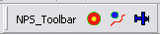

The NPS Toolbar contains the Buffer Tool, the Straightline Tool and the Transect Tool.

Animal Marking Applet Folder Contents

The Animal Marking ArcPad Applet can be found in the ‘Animal Tracking ArcPad Applet’ folder. The contents of the folder include the following:

- Image Files: These image files are used for the various button icons throughout the applet.

- Application Files: The files NPSApplet.vbs, NPSApplet.apa and NPSHelper.vbs contain the actual Animal Tracking applet.

- DBF files: The ‘Point Log’ DBF file is used to backup GPS points per Transect segment. The ‘default values’ DBF stores application data.

Animal Marking Applet Installation Steps

Navigate to ArcPad’s Applets folder which is in the ArcPad application folder (e.g. path ‘C:\Program Files\ArcPad 7.1\Applets’). Please remove any existing Applets and/or other content from this folder.

Copy the ‘ArcPad Survey Tool’ folder’s contents to ArcPad’s ‘Applets’ folder.

Start ArcPad and ensure you can now see a toolbar with the text ‘NPS Animal Marking’ visible. This indicates that the installation was successful.

The Animal Marking applet also comes with the well known ArcPad FakeGPS extension. To install the extension, simply copy the ‘Fake GPS Extension’ folder’s contents to the ArcPad’s ‘Extensions’ folder which is in the ArcPad application folder (e.g. path ‘C:\Program Files\ArcPad 7.1\Extensions’).

NPS ArcMap Layers

NPS_Transect_Tool.mxd Layers

The purpose of the NPS Animal Tracking Project is to collect sighting data and the purpose of the NPS layers is to help display that sighting data. The following sections describe each layer in the NPS_Transect_Tool MXD and explain the data each layer displays. All the layers and their data sources are in the NAD_1983_Alaska_Albers coordinate system.

Horizon Layer

The Horizon layer stores points that represent the horizon distance. This layer is populated with data from the Animal Marking Applet.

DB animals Layer

The animals Layer contains the sightings collected through the Animal Marking Applet. Each sighting can be identified by its particular survey, transect and segment.

DB TrackLog Layer

The DB Tracking layer displays the on and off transect segments generated from surveying a Transect.

GPSPointsLog Layer

The GPSPointsLog layer holds all the GPS fixes obtained during the flight of a survey.

Random Points Layer

Random points specify locations where the Transect tool will attempt to generate Transects. Random points are always outside of excluded areas and may or may not fall within flat areas. Random points are generated by Step 3 in the Transect tool.

Generated Transects Layer

The final product of the Transect tool is Transects. Transects represent flight paths for the aerial survey. Sightings are only collected while flying over these Transects.

Flat Areas Layer

Flat areas are areas that are considered to be flat based on a specified slope.

Excluded Areas Layer

Excluded areas are spots that are within an excluded range.

Survey Boundary Layer

Survey boundaries represent the area of survey. All flat areas, excluded areas, random points and Transects must fall within the bounds of the survey area for which they were generated.

Transect Generation Tool Usage

The Transect Generation tool generates Transect lines drawn at random angles and at random locations within a particular survey boundary.

Survey Boundaries

Survey boundaries specify an area of study for a particular survey. These survey boundaries exist as polygons in the Survey Boundary map layer of the NPS_Transect_Tool MXD. Survey boundaries also specify where transects will be generated and thus the Transect tool cannot work without them. There are two methods to create survey boundaries in the NPS Animal Tracking Project; digitize or import.

Digitizing Boundaries

Digitizing boundaries means opening an ArcMap edit session and sketching out a boundary polygon. To digitize a new survey boundary, perform the following steps:

- Open the NPS_Transect_Tool MXD

- Click on the Editor button, in the Editor toolbar, to reveal the Editor options. Select Start Editing. ArcMap should now be in an edit session. A ‘Start Editing’ window will open and ask you to pick the folder or database that has the layers and tables that you want to edit. Pick the source location of the NPS_Transect_Tool geodatabase and you should see a list of the layers from step 2 above (e.g., Horizon, DB animals . . . Survey Boundary).

- If you do not see an Editor button, right-click on the upper region of ArcMap to view a list of toolbars. Select the Editor option from the list to open the Editor toolbar as an undocked window. To dock the Editor toolbar, drag and drop the toolbar unto the upper region of ArcMap near the other docked toolbars.

- On the Editor toolbar , set the Task dropdown list to Create New Feature and set the Target dropdown list to Survey Boundary. Click the pencil icon to go into sketch mode.

- Sketch out the desired polygon shape. A DEM file or shapefile will need to be used as a background reference for users to trace along.

- When you complete the sketch, the New Survey Boundary window will open.

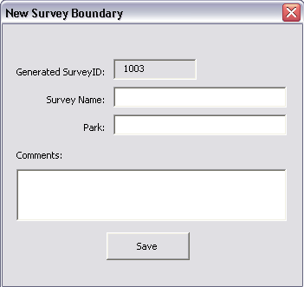

- The New Survey Boundary form is a tool to help record information on the new survey boundary. The auto-generated SurveyID is displayed in a read-only field. If the New Boundary window did not open, try restarting ArcMap.

- Enter a survey name, description (Comments) and Park for the new survey boundary and click OK.

- Click on the Editor button again and select Save Edits. Alternately, click Stop Edits and choose YES when asked to save edits.

- To confirm that your new survey boundary is valid, open the Transect tool (click the button with the blue airplane icon on the NPS Toolbar) and make sure you can select your survey by survey name from the survey dropdown list.

Importing Boundaries

Survey boundaries may also be imported through Shapefiles. The Shapefile, containing the polygons to import, must be in the NAD_1983_Alaska_Albers coordinate system. If it is not, the Shapefile can be projected to that coordinate system using the ArcToolbox’s Project tool (Data Management Tools → Projections and Transformations → Project). To Project tool’s window, select the Import Coordinate System option and select one of the FeatureClasses of the NPS database.

If while importing, an ‘invalid grid size’ error occurs, use the Remove Spatial Index tool (Data Management Tools → Indexes → Remove Spatial Index) to remove the existing grid and try importing the Shapefile again. To import survey boundaries from a Shapefile, perform the following steps:

- Open the NPS_Transect_Tool MXD

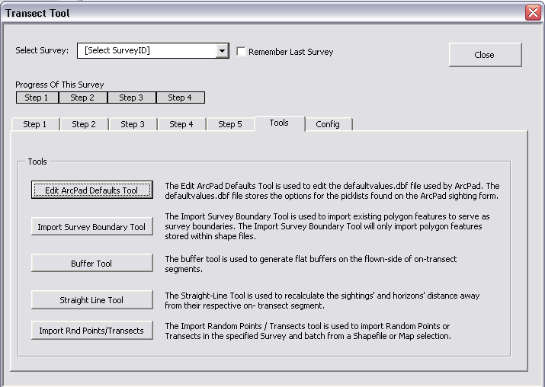
- Click on the Transect tool button on the NPS Toolbar. The Transect tool window will open:

- Click on the Tools tab and click the Import Survey Boundary Tool button to open the Import Survey Boundary tool window.

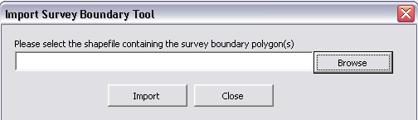

- Click the Browse button and browse to the Shapefile that needs to be imported. Click Open to select the Shapefile. If the Shapefile is in an incompatible coordinate system, an error will be reported.
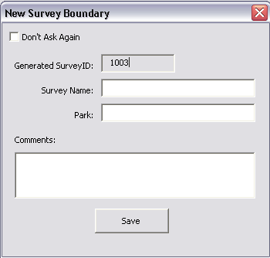
- Click the Import button to import the Shapefile’s features as survey boundaries.

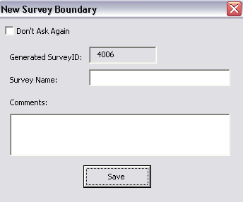
- For each survey area imported, the New Survey Boundary form opens to allow the user to enter a survey name and description for the currently imported survey boundary.

- The auto-generated SurveyID is displayed in a read-only field. The survey name is the name that will appear in the Select Survey dropdown list of the Transect tool. If no survey name is specified, the SurveyID will show up in the dropdown list. The user can check the Don’t Ask Again checkbox on the New Survey Area form to simply import the areas without entering data for each area. If the import shapefile has fields named Comments and SurveyName, the Import Survey Boundary Tool will never open the New Survey Boundary form and all data for the new survey boundaries will come from those fields.

- To confirm that your new survey boundary is valid, open the Transect tool (click the button with the blue airplane icon on the NPS Toolbar) and make sure you can select your survey by survey name from the survey dropdown list.

Edit ArcPad Defaults Tool

The Animal Tracking ArcPad Applet contains many pick lists. There are pick lists for setting survey-wide data like observers, pilot, plane, etc. and there are pick lists for describing animal sightings such as cloud cover and animal type. All these pick lists obtain their data from a file called defaultvalues.dbf. This file is packaged with the data exported for the Animal Tracking ArcPad Applet. The Edit ArcPad Defaults tool is the tool used to edit the defaultvalues.dbf file and thus modify the pick list options.

To modify the defaultvalues.dbf file, do the following:

- Open the NPS_Transect_Tool MXD
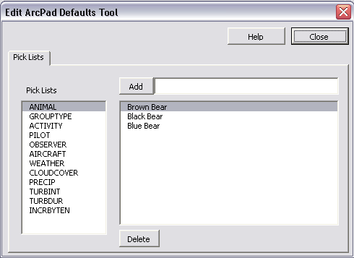
- Click on the Transect tool button on the NPS Toolbar. The Transect tool window will open

- Click on the Tools tab and click the Edit ArcPad Defaults Tool button to open the Edit ArcPad Defaults Tool window.

- To the left is a list of all the pick lists used by the Animal Tracking ArcPad Applet. Select the pick list to edit. The current options for the selected pick list will be displayed to the right.

- To add a new option to the pick list, type the text for the new option in the Add field and click the Add button.

- To delete an existing pick list option, selection the option and click the Delete button below.

Whatever changes are made to the pick lists will be included with the next export (see 2.8 Export Data).

Setting a DEM

Another important step in using the Transect Generation tool is ensuring that the tool knows where to find a DEM file. Most of the steps in the Transect Generation tool require a DEM file to generate their results. To set the tool’s default DEM file, on the Transect tool window, click the ‘Config’ tab.

Click the ‘Browse’ button next to the ‘DEM File Path’ field and browse to the location of the DEM file you wish to use. Click the DEM file to select it. The path to the DEM file should now be set in the ‘DEM File Path’ field.

It may become necessary to re-project a raster to that of the ‘Survey Boundary’ FeatureClass projection if the raster doesn’t align with your boundary (the error message ‘the boundary polygon for SurveyID [SurveyID] is out of range of the Raster extent’ will indicate so).

To re-project the raster, open ArcToolbox. Right click within the ‘ArcToolbox’ window and click ‘Environments’. In the Environment Settings window, click General Settings and update the Current Workspace and Scratch Workspace fields to ‘C:\Temp’ and click OK. This will avoid any security issues that may come up while performing necessary processing on the raster.

Next, from the ArcToolbox, navigate to Data Management Tools→Projections and Transformations→Raster→Project Raster. From the Project Raster window, select the path to your raster and select a path and name for the output raster (the name must be less than 13 characters). Set the output Coordinate System by navigating to and selecting the ‘Survey Boundary’ FeatureClass. Click OK to create your new raster.

The Progress bars

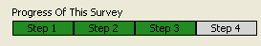
The four main Transect Generation tool steps - ‘Generate Excluded Areas’, ‘Generate Flat Areas’, ‘Generate Random Points’ and ‘Generate Transect Lines’ – all generate features for a particular SurveyID. At any point in time, a particular SurveyID may or may not have features generated by one or more of the tool steps. For example, a certain SurveyID may have flat areas generated but no random points while another SurveyID may have flat areas and random points but no Transects generated. This is where the progress bars come in.

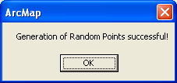
Directly above the main tabs (e.g. ‘Step 1’ tab) are the survey progress bars. Notice that each progress bar shares the same name as the tab it sits directly above. This is because each progress bar indicates the status of the Transect tool step with which it shares its name. The progress bars indicate whether any of the four steps were run for a particular SurveyID (green if features exist for a particular SurveyID and gray if not). The process for each step can take some time depending upon the Survey Boundary area, the DEM and the settings that you select for each step. When the step is finished processing, you will get a pop-up such as the following for Step 3 – Generation of Random Points:

Generate Excluded Areas (Step 1)

The ‘Generate Excluded Areas’ step uses a DEM to generate polygons of areas that are above or below the specified elevation. These polygons will be deemed as excluded areas and random points and Transect lines will not be generated within these polygons.

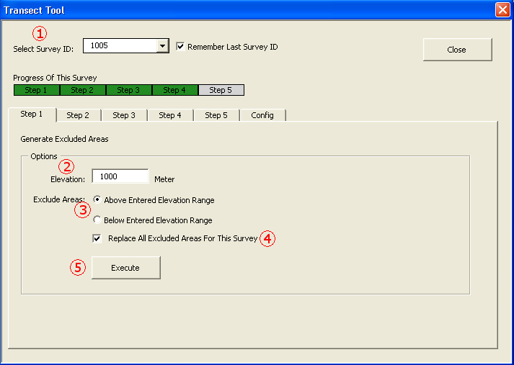
- First ‘Select the SurveyID’ of the survey boundary for which you wish to generate excluded areas. Excluded area polygons will only be generated within the selected survey boundary.

- Next, enter an elevation value. The unit of elevation is determined from the DEM which will be, more often than not, in meters.

- Select whether the areas above or below the specified elevation value will be excluded. If ‘Above Entered Elevation Range’ is selected then all areas/cells in the DEM file with elevation values above the specified elevation value will be extracted and converted to polygons and the adjacent polygons aggregated. If ‘Below Entered Elevation Range’ is selected then all areas/cells in the DEM file with elevation values below the specified elevation value will be extracted and converted to polygons and the adjacent polygons aggregated.

- Check the ‘Replace All Excluded Areas for This Survey’ checkbox if you wish to delete existing ‘Excluded Area’ polygons for this SurveyID.

- Finally, click the ‘Execute’ button to run the ‘Generate Excluded Areas’ step. The resulting polygons will be stored in the ‘ElvPoly’ FeatureClass (‘Excluded Areas’ layer in the NPS_Transect_Tool MXD file).

Generate Flat Areas (Step 2)

The ‘Generate Flat Areas’ step uses a DEM to generate polygons of areas that are within a specified slope range. These polygons will be deemed as flat areas and only straight Transect lines – not contour lines - will be generated within these polygons.

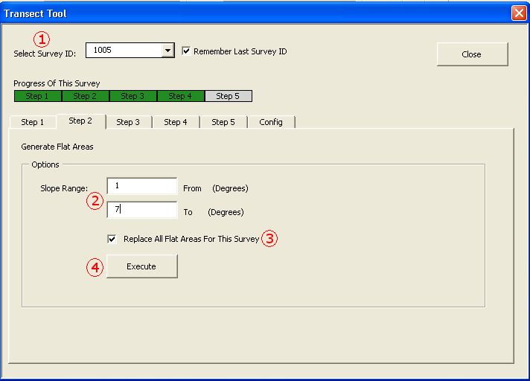
- First ‘Select the SurveyID’ of the survey boundary for which you wish to generate flat areas. Flat area polygons will only be generated within the selected survey boundary.

- Next, enter a slope range by entering slope values in the ‘From’ slope and ‘To’ slope fields. The ‘Generate Flat Areas’ step works by running an ESRI tool to calculate a slope value for each cell in a DEM. When the observer clicks the ‘Execute’ button, the cells with slope values within the specified range will be converted to polygons and the adjacent polygons aggregated.

- Check the ‘Replace All Flat Areas for This Survey’ checkbox if you wish to delete existing ‘Flat Area’ polygons for this SurveyID.

- Finally, click the ‘Execute’ button to run the ‘Generate Flat Areas’ step. The resulting polygons will be stored in the ‘FlatAreas’ FeatureClass (‘Flat Areas’ layer in the NPS_Transect_Tool MXD file).

Generate Random Points (Step 3)

The ‘Generate Random Points’ step generates points which are later used as centers of origin for Transect generation. Before points can be generated for a SurveyID, excluded area polygons must already exist for that SurveyID. The two methods used to generate points are ‘Random Generation’ and ‘Grid Format’. The ‘Random Generation’ method creates a specified number of points at random locations which fall within the selected SurveyID’s boundary but outside of any excluded area polygons.

The ‘Grid Format’ method generates points in a grid with a specified grid spacing distance. The ‘Grid Format’ method may generate grid points with or without a specified starting point. If no starting point is specified, the ‘Grid Format’ method will simply generate the grid points using the upper-left corner of the survey boundary’s envelope as a starting point. If a starting point is specified, the grid will be generated with the starting point as its center point.

- First ‘Select the SurveyID’ of the survey boundary for which you wish to generate random points.

- To use the ‘Random Generation’ method, select the Random Generation option and enter the number of points to be generated.

- To use the ‘Grid Format’ method, select the Grid Format option, specify a starting X and Y coordinate (must be in the coordinate system of the NPS database – NAD_1983_Alaska_Albers) if desired and set the distance between grid points (point spacing).

- Check the ‘Replace All Random Points for This Survey’ checkbox if you wish to delete existing random points for this SurveyID.

- Finally, click the ‘Execute’ button to run the ‘Generate Random Points’ step. The resulting points will be stored in the ‘TrnPoints’ FeatureClass (‘Random Points’ layer in the NPS_Transect_Tool MXD file).
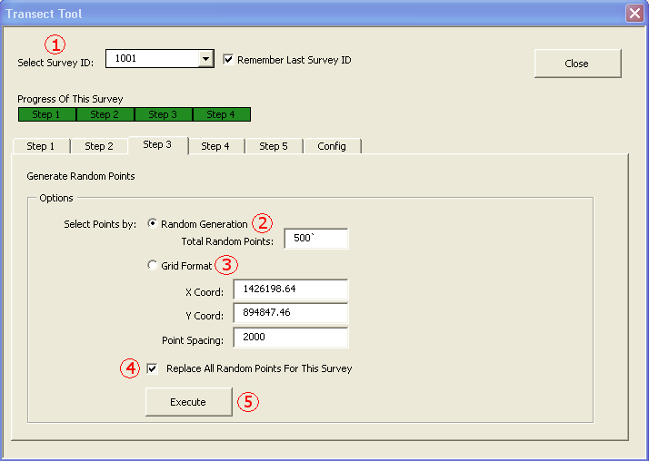

Generate Transect Lines (Step 4)

After excluded areas, flat areas and random points have been generated, it’s time to build Transect lines. Random points are selected and used as points of origin from which Transects are drawn. Transect lines may be straight Transects or contour Transects.

Straight Transects are Transects which completely fit within the flat area polygons and the survey boundary but are completely outside of the excluded areas. Contour Transects are Transects which are completely outside of the flat area polygons and excluded areas polygons but are within the survey boundary. Contour transects follow elevation contours (curved lines), while the flat area Straight Transects are 2 straight lines originating from a single point and drawn at random angles.

- First ‘Select the SurveyID’ of the survey boundary for which you wish to generate Transect lines.
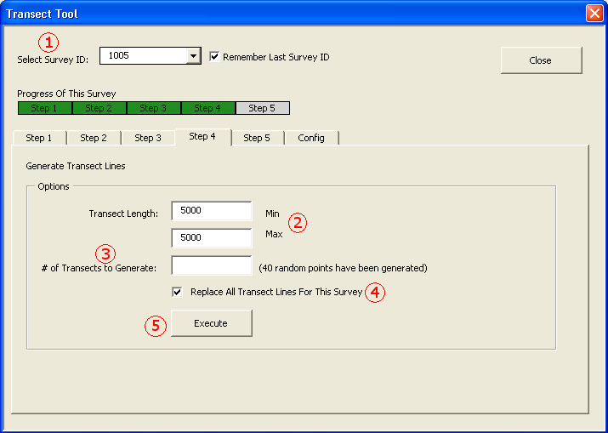
- Next, specify the minimum and maximum length of the Transects to generate. The units are always in meters (regardless of map units) which is the units of the NPS database. The ‘Generate Transect Lines’ process attempts to draw transects to the maximum length first and if the resulting Transect is invalid (falls within excluded areas or outside the survey boundary) the ‘Generate Transect Lines’ process will then attempt to draw the Transect line at the minimum length. If the Transect cannot be drawn at the minimum length, the random point used as the point of origin will then be marked off as abandoned by setting the ‘HasTransect’ field of the random point feature to ‘N’.

- The observer will also need to specify the number of Transect lines to generate. It should be noted that an observer can only create as many Transect lines as there are random points. If the ‘# of Transects to Generate’ field is left blank, the ‘Generate Transect Lines’ process will attempt to generate Transects for every random point for the selected SurveyID.

- Check the ‘Replace All Transect Lines for This Survey’ checkbox if you wish to delete existing ‘Transect Lines’ polygons for this SurveyID.

- Finally, click the ‘Execute’ button to run the ‘Generate Transect Lines’ step. The resulting polygons will be stored in the ‘TrnOrig’ FeatureClass (‘Generated Transects’ layer in the NPS_Transect_Tool MXD file).

Importing Transects/Random Points

Transects and random points can be imported into the NPS database and assigned to a survey using the Import Rnd Points/Transects tool. Random points and Transects can be imported from a shapefile or directly from a selection made from the map. The selection of random points or Transects from the map cannot be from an existing NPS layer. To import transects or random points, do the following:

- Open the NPS_Transect_Tool MXD

- Choose the Transects or random points to import by either identifying the shapefile they are contained in or adding them to the map and selecting those that will be imported. Note, a DEM file would need to be set in the Config tab and it would need to cover the area of all the Transects or random points to import.

- Click on the Transect tool button on the NPS Toolbar. The Transect tool window will open.

- Select the Tools tab and click on the Import Rnd Points/Transects button to open the tool.
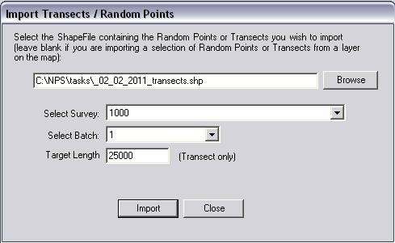
- If a selection of transects or random points have already been made, the survey and batch pick lists will already be enabled. If not, the survey and batch pick lists will be disabled until the user browses to the shapefile containing the Transects or random points to import and selects the file.

- Select the survey the Transects or random points will be added to. The default batch (batch 1) will be selected automatically. If there are multiple batches of transects or random points within the selected survey, the user can select which batch to import to. New batches are created when the user unchecks the Replace All Random Points/Transects for This Survey checkbox before generating random points or Transects.

- If Transects are being imported, a Target Length must be specified. The Target Length is the length at which an observer will be alerted of when they’ve flown past it.

- Click the Import button, to import the Transects or random points.

Export Data (Step 5)

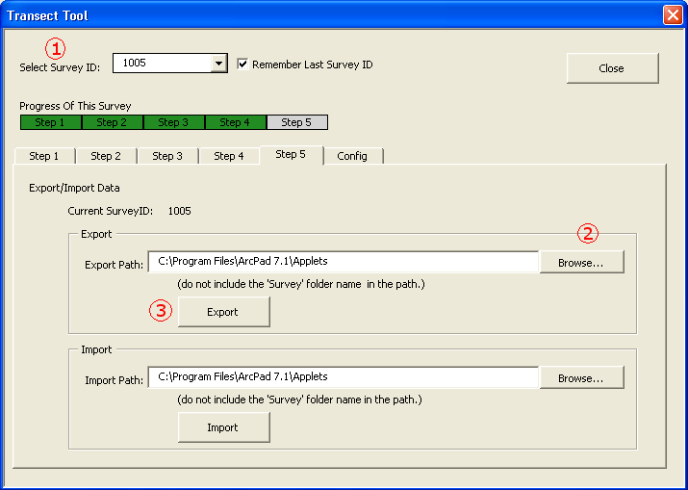
After successfully generating Transect lines for a particular SurveyID, the SurveyID Transect lines may now be exported. The ‘Export/Import Data’ tab (Step 5 tab) is where the Transects generated can be exported to Applet shapefiles, and the data collected in the field can be imported back into the geodatabase.

- First ‘Select the SurveyID’ of the survey boundary for which you wish to export data.

- Click the ‘Browse’ button next to the ‘Export Path’ field and navigate to the path of the storage device you wish to export to. Click the folder to select it. See screen shot below: the Survey folder will be exported to C:\Program Files\ArcPad 7.1\Applets. Typically you will export to a USB thumb drive so that you can transfer the Survey folder to the field PC or slate that you will use in the plane to record data. The path to the folder should now be in the ‘Export Path’ field.
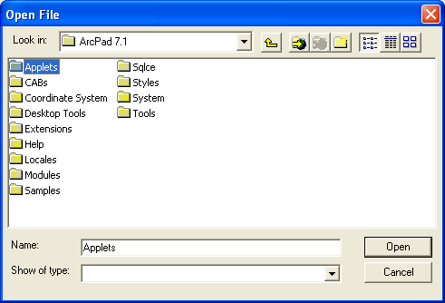
- Click the ‘Export’ button to export the data folder to the specified device or location. The data folder is named ‘Survey’ and includes the following:

- ‘TrnOrig’ Shapefile-Has all the Transects for the SurveyID that was selected.

- ‘animals’ Shapefile-An empty Shapefile for storing animal sightings

- ‘Track Log’ Shapefile-An empty Shapefile for storing the actual transect flight path

- ‘Horizon’ Shapefile-An empty Shapefile for storing horizon marks for animal sightings

- ‘GPSPointsLog’ Shapefile-An empty Shapefile for storing all GPS points obtained during the entire flight

- APL files for each of the Shapefiles mentioned above. These APL files contain the symbology for displaying the Shapefile features. This includes not only the colors but the symbols used to represent the shapes.

Import Data (Step 6)

After Transects have been flown, the Shapefiles exported in the Export process should now contain data collected in the field. This import data may include: animal sightings, horizon markers, flight track log, GPS point log and updated records in the Transect Shapefile.

- First ‘Select the SurveyID’ of the survey boundary for which you wish to import data.

- First, click the ‘Browse’ button next to the ‘Import Path’ field and navigate to the path of the Survey folder. It’s important to note that the Survey folder should not be part of the path – the import path should be the path to the Survey folder not the path to the Survey folder contents.

- Next, click the ‘Import’ button to perform the import process. The import process performs the following actions:

- The import process will first ensure that all Shapefiles – ‘animals’, ‘Track Log’, ‘Horizon’ and ‘GPSPointsLog’ – are in the Survey folder.

- The import process will then determine the TransectID of the Transects that were flown and have data to import.

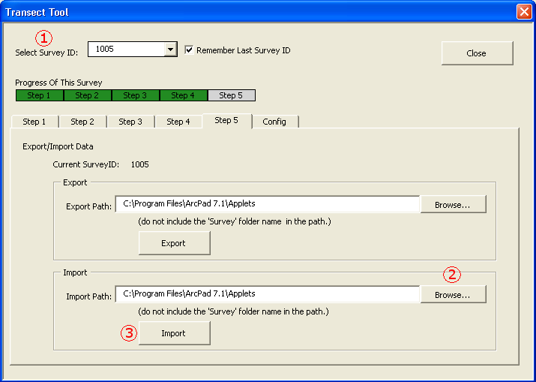
- The import process will determine if data already exists for any of the Transects flown and alert the observer. The observer will then have the option to abort the import process or override the existing data. If the observer chooses to override the existing data, then all existing data will be deleted for the Transects with existing data. The import process will then copy all the data from the Shapefiles into their corresponding FeatureClasses – the Shapefiles are named after the FeatureClasses they were generated from.

Configuration

The ‘Configuration’ tab allows the observer to set the ‘DEM File Path’ (see 2.2) and the ‘Max Attempts’ field. This tab is also described in step 3.5; setting the DEM is required before you can go through the process of generating your transects.

- To set the DEM file see section 2.2

- When setting a DEM file, always specify the units of that DEM in the DEM File Units dropdown. This will determine how certain information fields are populated

- The ‘Max Attempts’ is the number of times the ‘Generate Transect Lines’ step will attempt to draw the Transect at a random angle. The smaller the value specified is the fewer the attempts made at drawing the Transect (and the higher the change of a point being abandoned) but the quicker the step will run. The greater the value specified is the more attempts made at drawing the Transect (and the lower the change of a point being abandoned) but the slower the step will run.

- The Perform Checks button runs a series of tasks to check if a particular ArcMap environment is capable of properly running the NPS Transect Tool processes. Sometimes, during support, a representative may ask for the checks to be run and the results copied in a response email

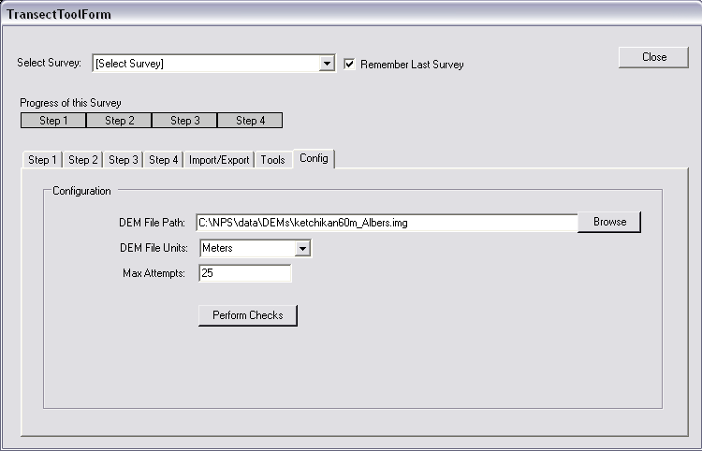

Buffer Tool

After importing sighting data, the on/off transect segments (not the same as the generated transects) are imported and displayed in the DB Tracklog layer. The Buffer tool is used to create buffers for these segments. The generated buffers are on the side the segment was observed and represent the viewable area of an observer from within the plane. To use the Buffer tool, do the following:

- Open the NPS_Transect_Tool MXD

- Specify a segments subset on the DB TrackLog layer if desired. The Buffer tool can buffer the whole database of on/off transect segments or just a subset. A subset can be specified via a selection set or a definition query.

(To create a selection set in ArcMap, either manually select features from the map using the selection tool or use the selection wizard in the upper-left menu of ArcMap. Definition Queries are filters set on attribute values in a layer. They may be used to filter segments by SurveyID. For example, the Definition Query ‘SurveyID=1004’ will cause the DB TrackLog layer to only display segments that have their SurveyID field/attribute set to 1004. For more help on setting Definition Queries on layers or creating selection sets in ArcMap visit ESRI help at: http://webhelp.esri.comz/arcgisdesktop/9.3/index.cfm?TopicName=welcome.)

- Click on the Transect tool button on the NPS Toolbar. The Transect tool window will open

- Click on the Tools tab and click the Buffer Tool button to open the Buffer Tool window. If a subset is specified, the Buffer Tool will inform the user of the filter(s) (selection set or definition query) in the information panel to the right.
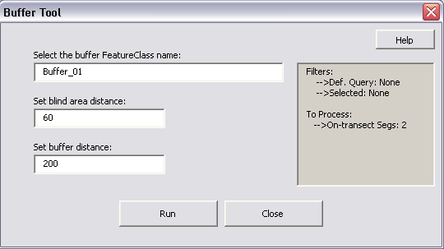
- Select the name of the FeatureClass where the buffer polygons will be stored.

- Select the blind area distance. The units are in meters which is the units for the NPS database. This is the area under the plan that is not visible.

- Specify the buffer distance. This is the distance from the viewable area of the plan to the specified distance. The units are in meters which is the units for the NPS database.

- Click Run to create buffers.

After the buffers are generated, they will be displayed on the map via a new layer with the same name as the name of the buffer FeatureClass.

Straight Line Tool

During post-processing of on/off transect segments (viewable from the DB TrackLog layer) some segments may need to be edited. After editing the segment’s geometry, the segment’s sightings and horizons distance to the nearest segment value may become invalid. The purpose of the Straight-line tool is to recalculate the distance the sightings or horizons are away from the nearest segment on the Transect they were observed.

To use the Straight-line tool, do the following:

- Open the NPS_Transect_Tool MXD.

- If the user wishes to recalculate the distances for only a subset of horizons and sightings, select those sightings/horizons from the map. To recalculate the distance of all horizons and sightings, simply run the tool as is.

(To create a selection set in ArcMap, either manually select features from the map using the selection tool or use the selection wizard in the upper-left menu of ArcMap. Definition Queries are filters set on attribute values in a layer. They may be used to filter segments by SurveyID. For example, the Definition Query ‘SurveyID=1004’ will cause the DB TrackLog layer to only display segments that have their SurveyID field/attribute set to 1004. For more help on setting Definition Queries on layers or creating selection sets in ArcMap visit ESRI help at: http://webhelp.esri.comz/arcgisdesktop/9.3/index.cfm?TopicName=welcome.)
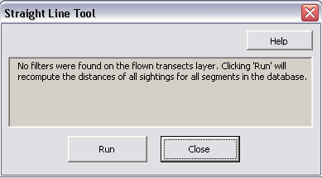
- Click on the Transect tool button on the NPS Toolbar. The Transect tool window will open.

- Click on the Tools tab and click the Straight Line Tool button to open the Import Straight Line tool window. If a subset is specified, the Straight Line Tool will inform the user of the filter(s) (selection set or definition query) in the information panel.

- Click Run to execute the Straight Line tool.

Mark Animal Applet Usage

The Mark Animal Applet facilitates the collecting of animal sighting data during a transect flight. The applet is designed to work with the ‘Survey’ folder created from the Transect Generation tool’s export process.

To begin using the Mark Animal applet, complete the applet installation instructions in 1.4 (if not already completed) then open ArcPad. ArcPad should display the Mark Animal applet icons as shown in figure 3.1 below. This indicates that the applet was installed successfully and is ready for use.

Fig 4.1
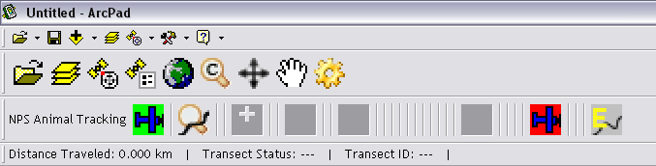

The Survey Folder

The first step in using the Mark Animal applet is to copy the Survey folder to the ArcPad Application folder’s Applets subfolder. The ‘Survey’ folder is the folder generated from the Transect Generation tool’s export process. The path to the ArcPad Application folder may vary depending on where you installed ArcPad. For more information on the Survey folder, see section 2.8.

Restoring Segment after ArcPad Fails

When the user begins an Off-Transect or On-Transect segment, the GPS points being collected are not only stored in memory but are being backed up in a DBF file called PointLog. In the event ArcPad crashes while a Transect is being flown, the segment may be generated from the backup points up to the point when ArcPad crashed.

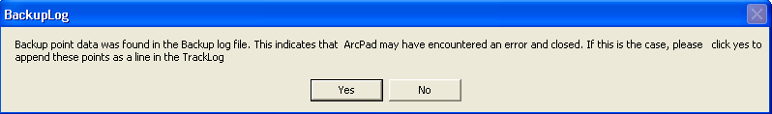
To restore the segment, simple restart ArcPad and click the Take Off /Load Map button. The Mark Animal applet will detect backup points in the DBF file and offer to restore them as a segment. Choose ‘Yes’ to restore the segment or ‘No’ to clear out the points from the log. To resume flying the Transect, fly to the end of the restored segment, select the Transect, and then click the Start Transect button. If the crash occurred during an off-Transect segment, clicking the Start Transect button will automatically open the Animal Mark form.

Take Off/Load Map
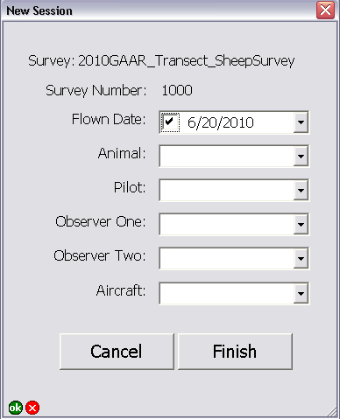

When the pilot takes off, the Take Off /Load Map must be clicked to signal to the Mark Animal applet that it should begin tracking the planes GPS flight path. Click the Take Off /Load Map button to load all the Shapefiles from the Survey folder as layers in the ArcPad map. If any Shapefiles or necessary files are missing, an error message will indicate which files are missing and the applet will not allow the observer to progress until all the necessary files are present.

The Take Off /Load Map button will automatically open the New Session form. From here, the user will specify an animal from the Animal pick list. The Animal pick list determines the form that will be used to collect sighting data. Currently, there are only three available forms; bear and sheep – long and sheep – short. At a minimum, the animal, pilot and first observer must be entered for the session to begin.

After filling out all the required fields click Finish to complete the Load Map step.

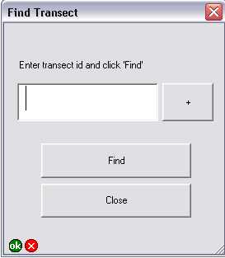
Find a Transect

Now that we have an active session, it’s time to start flying transects. Find Transect tool can help with finding transects to fly. This tool is in the NPS Animal Tracking toolbar with the binoculars icon. To use the Find Transect tool, do the following:

- Anytime after the Take Off /Load Map button has been clicked, click the Find Tool to open the Find Tool window.
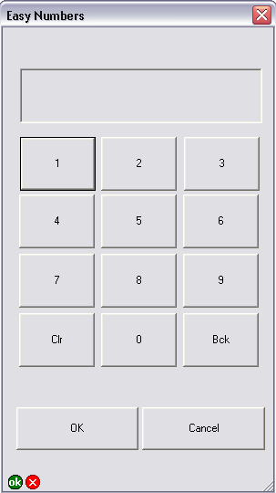
- Enter the ID for the desired transect. The button next to the TransectID field with the cross can be used to access the Easy Numbers form. This form allows users to use a number pad to enter number values rather than using the keyboard.

- Click the Find button to zoom to the Transect. If the Transect cannot be located, the Find Tool will inform the user so.

Select a Transect

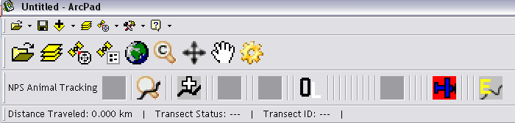
After completing the New Session form, the Select Transect (gray background) button will become available. The Observe Direction button will also appear which will allow the observer to toggle the observing. The button
OL will become OR when clicked which indicates the observer(s) has now switched from observing out the left side of the plane to observing out the right side.
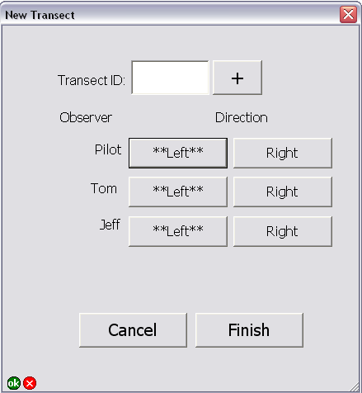
To select a Transect, click on the Select Transect (gray background) button. The Select Transect (gray background) button’s icon will change to (green background) to indicate it is now active and the New Transect form will open.

Click the (+) button to open up the number pad and enter the Transect ID of the next Transect to fly. Set the initial observer direction and hit Finish to complete Transect setup.

Start a Transect
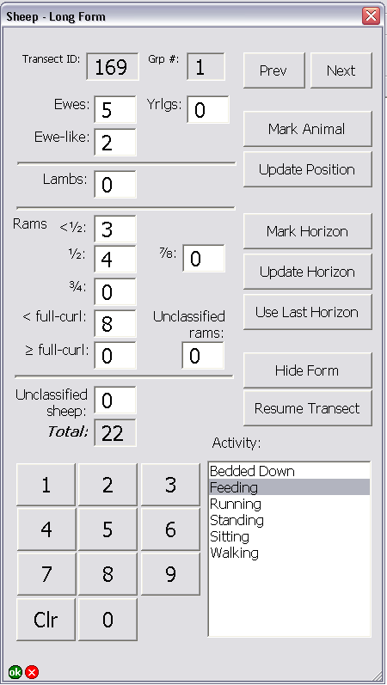
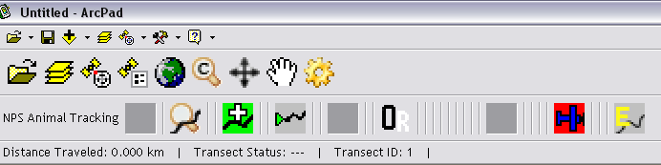
After completing the New Transect form, the Start Transect button will become available. If the GPS device is currently activated – or the FakeGPS extension is active – clicking the Start Transect button will signal to the Mark Animal applet to begin building segment lines for the Transect. If no GPS device is active, the Start Transect step will not run. Upon starting a Transect, the Mark Animal and End Transect buttons become available while the Start Transect, Take Off /Load Map and Select Transect buttons are disabled. The observer is currently in On-Transect mode.

Mark an Animal

While a Transect is being flown, the observer may see an animal and decide to go Off-Transect to mark it. Clicking the Mark Animal button will move the applet from On-Transect mode to Off-Transect mode. The form, which corresponds to the animal selected in the New Session form, will automatically open. If the user selected Sheep, they will see the Sheep form in the image below. If the user selected Bear, they will see the image on the next page. After clicking the Mark Animal button, a green line will appear showing the On-Transect flight path up to the point the plane went Off-Transect.

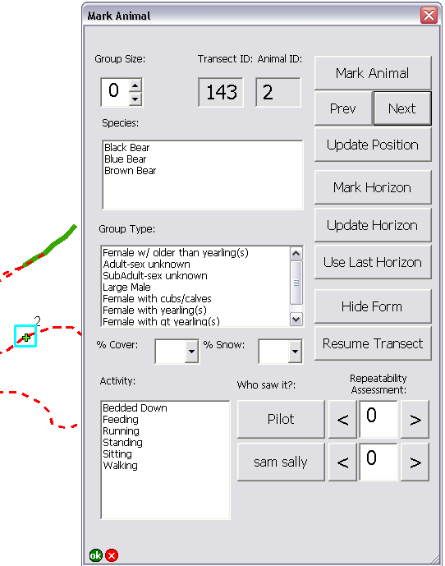
The ‘Mark Animal’ forms have automated the process of saving animal sighting information. When a new animal mark is created and the observer sets the sighting options, the record will auto-save if the observer creates another animal mark, navigates to another existing one (‘Prev’ and ‘Next’ buttons) or closes or pauses the form.

Clicking the ‘Mark Animal’ button on the form will create an animal sighting in the ‘animals’ Shapefile. A light blue square will be seen around the new mark. This indicates which animal mark is currently selected. The user should now go ahead and fill out the data for the sighting form they selected.

To mark a horizon (effective sighting distance) for an animal mark, first navigate to the desired mark with the ‘Prev’ and ‘Next’ buttons then click the ‘Mark Horizon’ button. You may also click the ’Use Last Horizon’ button to assign the last Horizon marked to the currently selected animal sighting.

Other features on the ‘Mark Animal’ forms include:

- ’Prev’ and ‘Next’ buttons: These allow the observer to select and edit any other animal mark created on the current off-transect segment. The newly selected feature can be identified by the light blue square around it. The options that were selected for that shape will be reloaded and any changes will be automatically saved by either creating another animal mark, navigating to another existing one or by simply closing or pausing the form.

- ’Update Position’ button: This button will adjust the location of the currently selected animal mark to the current position of the GPS device.

- ’Update Horizon’ button: This will update the position of the Horizon set for the currently selected animal mark to the current position of the GPS device.

- ’Use Last Horizon’ button: This button will assign the last horizon created to the currently selected animal mark.

- ’Hide Form’ button: This button allows the form to be hidden so the map may be accessed for zooming and panning. During hidden state, the only button available is the ‘Mark Animal’ tool button which is used to restore the form.

- ‘Remember Last Selection’ checkbox: When checked, the form options will not be cleared when ‘Mark Animal’ is clicked to create a new animal mark. This allows the options for the last animal sighting to be reused for the current animal sighting. When unchecked, the form options will clear each time a new animal sighting is created.

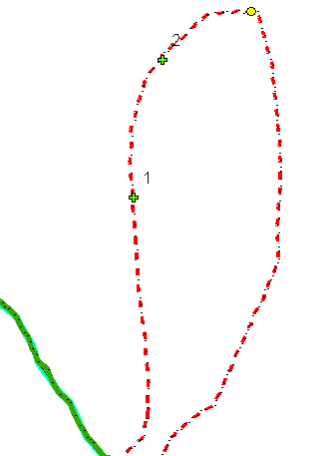
Clicking the Resume Transect button will close the form and signal to the Mark Animal applet that the observer has resumed On-Transect mode. A read dashed line will now be visible indicating the path flown from the moment the plane went Off-Transect up till the observer clicked the Resume Transect button.

Editing Animal Sightings
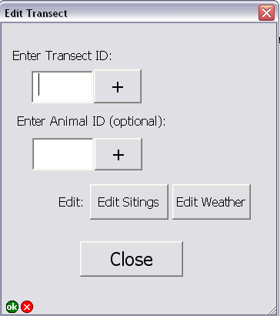
At any time outside of an off-transect session, a user can editing any sighting on any transect collected thus far. To edit a sighting(s) do the following:
Click the Edit Transect tool button to open the Edit Transect form.

Enter the Transect ID for the Transect which sightings you wish to edit. If you know the ID for a particular sighting, you can enter it to go directly to that animal sighting.

Click Edit to open up the form that was used to create the sighting. The form will open up in edit mode. When a form is in edit mode, horizons and sighting positions cannot not be updated and new sightings cannot be created – only data relating to the sighting can be edited.

Click Next or Prev to navigate through all the sightings within the selected transect and make changes where necessary. When all changes have been made, click the Close button to return to the Edit transect form.

From the Edit Transect form, the user cans select another Transect to edit or click Close to exit and return to the map.

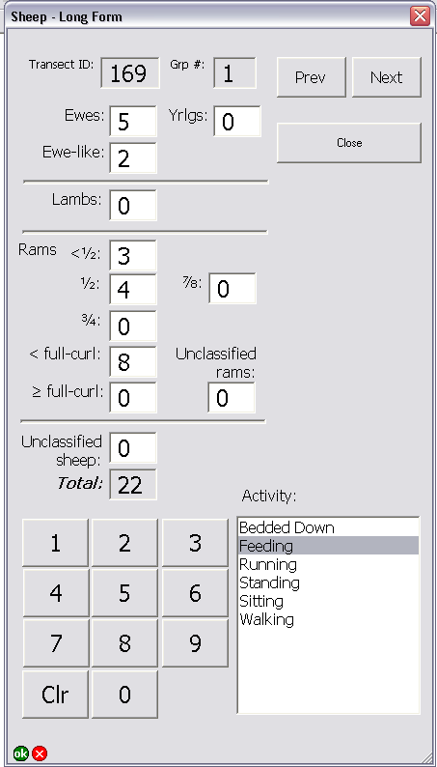

End a Transect

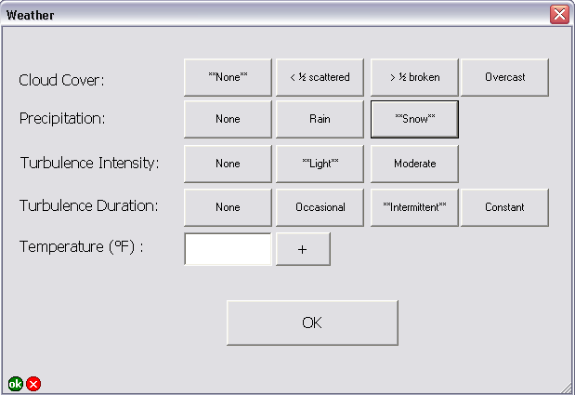
When the observer is through flying the Transect, the observer must then click the End Transect button to mark the Transect as completed. The Transect will change to a gray line to indicate that it has been flown. The Start Transect and Select Transect buttons will be restored to allow the observer to select and start flying another Transect. Finally, the Weather form will open to allow the user to specify weather conditions during the flight.
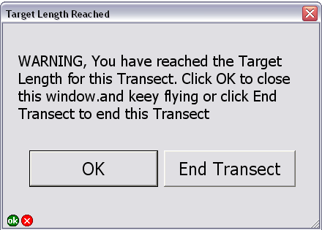
Sometimes, an observer may not realize that they have gone on flying past the Target Transect length, the length specified when the Transects were generated. A warning window will open to allow users to keep flying or End the Transect immediately.

Land

When the observer is through flying Transects for this flight, the pilot will return to the air strip. When the pilot lands, the Land button must be clicked to signal to the Mark Animal applet that it should stop tracking the GPS flight path.
It is now safe to close ArcPad and extract the Survey folder.

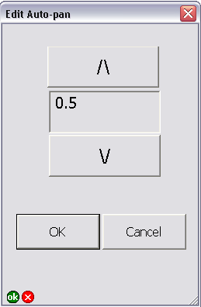
GPS Auto-Panning Percentage

The GPS auto-panning percentage is the percentage towards the edge of the screen that the GPS cursor must reach before the map is automatically panned. The GPS auto-panning percentage is expressed as a value between 0 and 1. Set the GPS auto-panning percentage to 0 to re-center the map at every new GPS fix. Set the GPS auto-panning percentage to 1 to turn automatic map panning off. All other values (>0, <1) represent the percentage towards the edge of the screen the GPS cursor must reach before the map automatically pans. For example, a GPS auto-panning percentage of 0.80 indicates 80% towards the edge. This tool is on the NPS Animal Tracking toolbar with the icon.

To edit the GPS auto-panning percentage, do the following:

- While the GPS device is active, click the Edit Auto-pan tool button on the NPS Animal Tracking toolbar. The Edit Auto-pan window will open.

- Click the Up arrow to increase the percentage or Down to decrease the percentage

- Click the Cancel button to abort editing the auto-pan settings.

- Click OK to save the new auto-pan settings and exit form.

Configurations for Transect Session

Before or during a flight, certain configuration settings can be altered to affect the way that ArcPad behaves. To access the Configuration form, select the Configuration button.

Configurations include:

Custom Zoom - This is the zoom level that is zoomed to when the Custom Zoom button is pressed. The number is a percentage of full extent.

Hide/Show Main Toolbar - This allows a user to hide the ArcPad toolbar, the top most toolbar.

Editing ArcPad Layer Symbology

The quickest way to edit the Survey folder’s APL symbology files is within ArcPad itself. Click Take Off /Load Map to load the map and click Cancel. Click on the Table of Contents icon to reveal a list of all the layers in the map. Double-click on the layer to open up the Layer Properties window and select the Symbology tab.

Go ahead and edit the symbology as desired. Now click ‘OK’ on all the windows till you only see the map and your new symbology changes. The trick now is to close the map, and you can choose to save the map anywhere. The map file is unimportant – the APL files in the Survey folder have now been updated with your symbology changes.

You can now replace the APL files in the Transect Generation tool’s APLs folder with these new APL files. The next time you export data, your symbology files will be exported. Note also that this was only tested in ArcPad 7.1.

Another way to edit the Survey folder’s APL symbology files is within ArcMap. If you have installed ArcPad 7.1 then the ArcPad Data Management extension for ArcMap should have also been installed. To add the ArcPad toolbar to ArcMap, go to Tools→Customize→Toolbars and select ArcPad Data Manager.

Now edit the layer symbology in ArcPad for the desired layer. Clicking the ‘Get Data for ArcPad’ button will open up the ‘Get Data for ArcPad’ wizard. Select the layers which symbology you edited and click next. Select a name and path for the folder you want the Manager to export the data to. Choose NOT to create an ArcPad map. Go to the folder you chose to export to. You should find APL files representing the symbology of the layers in ArcMap you chose to export along with Shapefiles.

You can now replace the APL files in the Transect Generation tool’s APLs folder with these new APL files. The next time you export data, you symbology files will be exported. Note also that this was only tested in ArcPad 7.1.

Post-processing

Editing NPS feature

During post-processing, it may become necessary to alter the geometry of some of the NPS features. Flown Transects may need to be clipped or repositioned due to errors in flight. When editing, please bear in mind the following:

The distance a sitting is from the nearest segment on a Flown Transect is set in a field on the animal and horizon features. When Flown Transects are modified, that field’s value becomes invalid. To correct the field’s value, rerun the Straight Line distance tool.

